Hands-on-activity Mysql
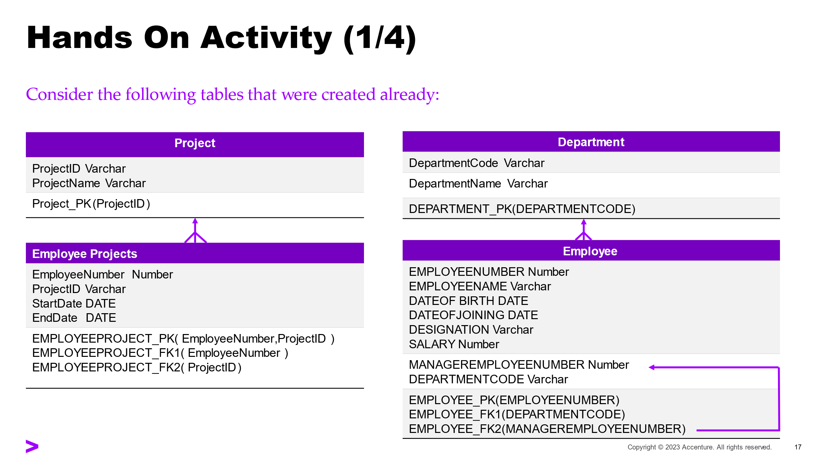

Questions :
- Display EmployeeName, Designation and Salary for ALL the employees
- Display different designations in the company (Each designation should be displayed only once)
- Display EmployeeName and Salary of SSEs whose salary is more than 35000
- Display EmployeeName, Designation and Salary of SM, SSE and SE
- Display EmployeeName and DateOfJoining of employees who have joined in the year 2000
- Display EmployeeName, DateofBirth and Age of ALL employees (Age is not a database column. Needs to be computed. In Oracle, SYSDATE contains the current date)
- Display EmployeeName and Salary of employees whose salary is in the range INR 50,000 to INR 100,000
- Display Employee Name, Salary of employees whose salary is more than the average salary of the department they belong to
- Display Employee Name of employees whose manager is younger than the employee
- Display EmployeeName of employees whose name starts with ‘J’
- Display EmployeeName of employees whose name ends with ‘k’
- Display EmployeeName of employees whose names contains ‘a’ as the second letter
- Display EmployeeName of employees whose names contains only three letters
- Display EmployeeName and Designation of MDs whose name starts with ‘M’
- Display EmployeeName and DateOfJoining of employees who have joined in the month of ‘MAY’
- Display EmployeeName and Salary of ALL employees in the alphabetical order (‘A’ to ‘z’) of EmployeeName.
- Display EmployeeName and DateOfBirth of ALL employees in the order of eldest to youngest
- Display EmployeeName and Salary of ALL employees in the decreasing order of Salary
- Display EmployeeName and Salary of ALL employees in the decreasing order of Salary and in the alphabetical order of (‘A’ to ‘z’) EmployeeName if the salary is same
- Display EmployeeName,Designation and Salary of TLs in the decreasing order of Salary
- Display EmployeeName, Salary of employees whose salary is more than the average salary of the company
- Display EmployeeName, Salary of employee(s) who is getting the lowest salary in the company
- Display EmployeeName of employees who are working in project ‘P1’
- Display ProjectName of projects which has more than 2 employees (Exclude rows if end date is not null)
- Display EmployeeName of Managers who have more than three team members
- Display the second maximum salary of the company
- Display the ProjectName of projects which currently does not have any employees
- Display Employee Name, Salary of employees whose salary is more than the average salary of the department they belong to
- Display Employee Name of employees whose manager is younger than the employee
- Display EmployeeName, ProjectId of ALL employees even if an employee is not assigned to any project .
- Display EmployeeName, ProjectId of ALL employees even if an employee not assigned to any project (Include only if EndDate is Null). Display “Not Allocated” if ProjectId is null

Schema 2:
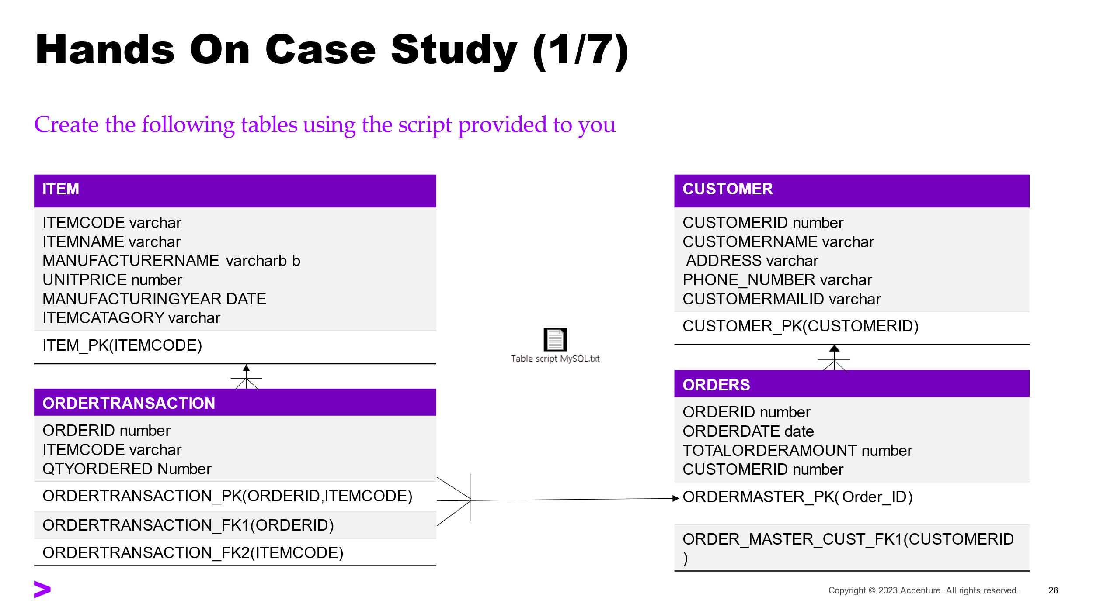
- Display ItemCode, ItemName and ItemCategory of items whose UnitPrice is less than INR 500
- Display ItemCode, ItemName and ItemCategory of items whose UnitPrice is in the range INR 10,000 to INR 20,000 (both inclusive)
- Display ItemCode and ManufacturerName of Televisions that are costing more than INR 15,000
- Display ItemName, ManufacturerName and UnitPrice of "Televisions, Mobiles and Washing Machines"
- Display ItemCode, ItemName and ManufacturerName of items which were manufactured in the year 2015.
- Display ItemCode, ItemName and ManufacturerName of Televisions which are more than 2 years old.
- Display ItemCode, ItemName, UnitPrice, UnitPrice+VAT for all "Refrigerators" (VAT to be computed as 2% of unitprice of the item).
- Display CustomerName and PhoneNumber of Customers whose name starts with ‘J’
- Display CustomerName and Phone of Customers whose name ends with ‘an’
- Display CustomerName and Phone of Customers whose name starts with 'M' and ends with 'n'
- Display CustomerName and Phone of Customers whose name contains only three letters
- Display CustomerName and Phone of Customers whose name contains 'a' as the second letter
- Display UnitPrice which is the maximum in the store
- Display the total number of items in the store
- Display ItemCode, ItemName, ManufacturerName and UnitPrice of ALL items in the descending order of UnitPrice.
- Display CustomerName and Address of customers in the alphabetical order (A to Z) of CustomerName.
- Display ItemCode, ItemName, ManufacturerName and UnitPrice of all items in the ascending order of UnitPrice and in the descending order of ManufacturerName (if UnitPrice is same).
- Display customerId and total number of orders placed by each customer.
- Display ItemCategory and average UnitPrice in each item category.
- Display customerId of customers who have placed more than 1 order.
- Display ItemCategory of items which has the minimum unit price more than INR 10,000.
- Display ItemCategory, total number of items for "Television" and "Refrigerator" if the total number of items exceeds 5. Display the results in the descending order of total number of items.

